Seesaw Home User Guide
To open your child’s account (Please also see step B if your children are sharing a device).

- Go to https://web.seesaw.me/ on a computer. Or install the Seesaw Class App on an iOS or Android device.
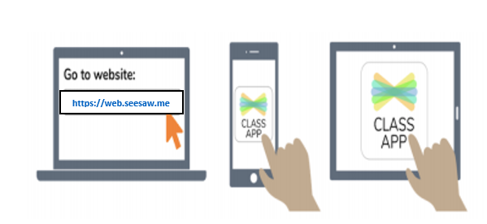

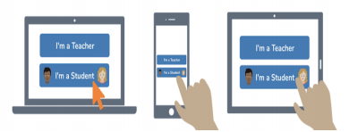
- Choose ‘I’m a Student’.

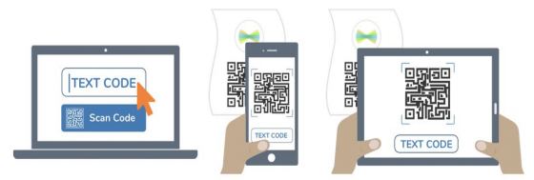
- Scan the QR Home Learning Code that has been provided for you (or type in the text code if you are on a desktop). This QR code is unique to your child’s Seesaw journal which they are also using at school and should not be shared with anyone else.

If your children do not need to share a device, they can now stay logged in.

Our children share a device – what do we do?

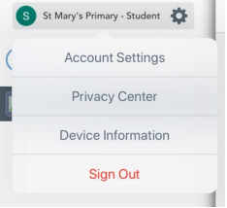
Your children will need to log in and out of their accounts using their individual QR codes to access their work each time.
To log out, click on the cog beside your child’s name and click ‘Sign Out’. To sign in as another child, follow steps 1 – 3 above.
Scanning a code and not typing in any usernames and passwords means the transition between the two classes will be quick to do.

Students - To complete an activity assigned by your teacher

- Go to the Activities tab.
- Listen to or read the instructions.
- Tap the ‘Add Response’ button.
- Your teacher will have provided you with a template to work on or an example of what to do.
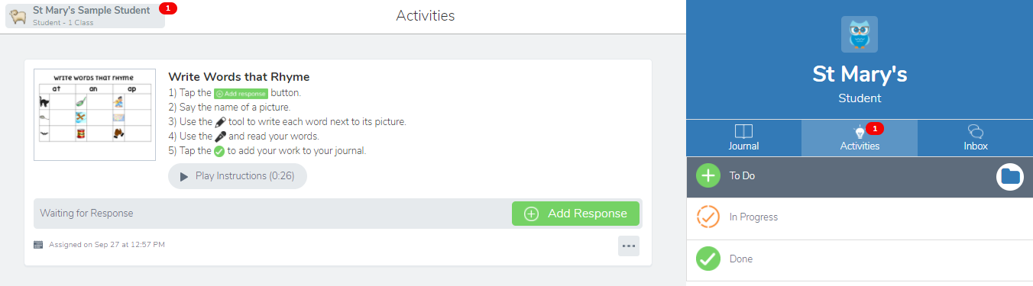

- Use the tools to help you complete the activity.
- If you can’t remember what to do, click ‘View Instructions’ again.

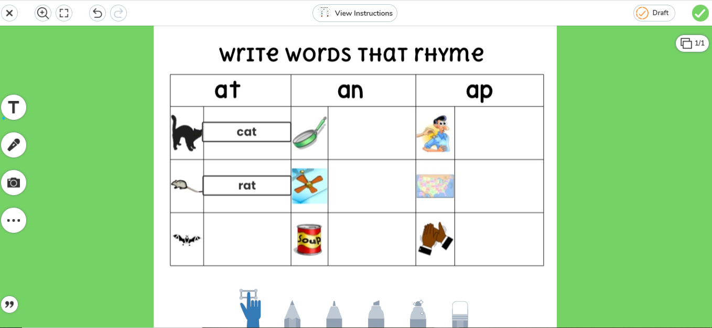

- Click the green tick to submit your activity to your teacher. If you are not finished the activity, click on ‘Draft’ and it will save your progress so far.
- If you need to make a change once you have submitted your work, go to your Journal and click on the … and select ‘Edit Post’.

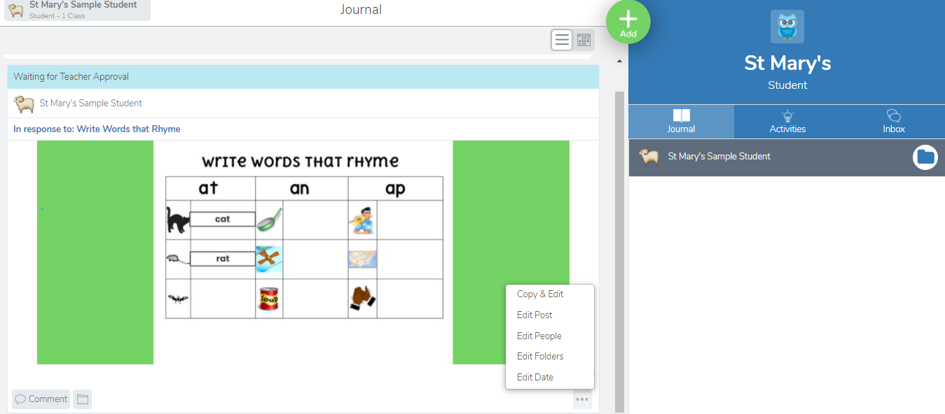

- Your teacher will approve your item and perhaps write a comment for you. You will receive notifications of any comments to the ‘Notifications’ section of your inbox.
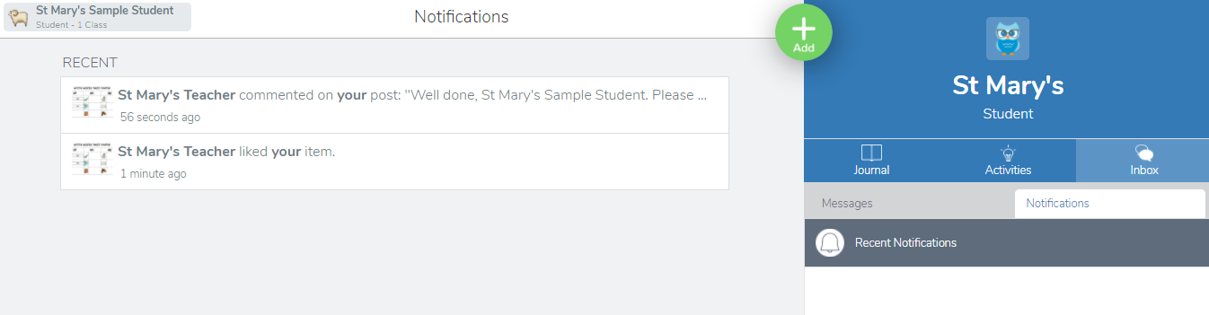

- Click on the notification to take you to your teacher’s comment. To complete any corrections you may have been given, click on the … and click on ‘Edit Post’.
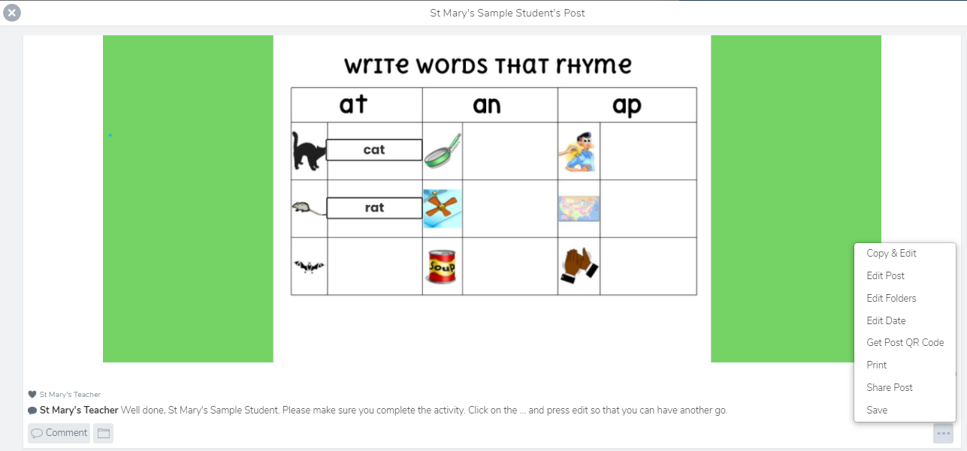

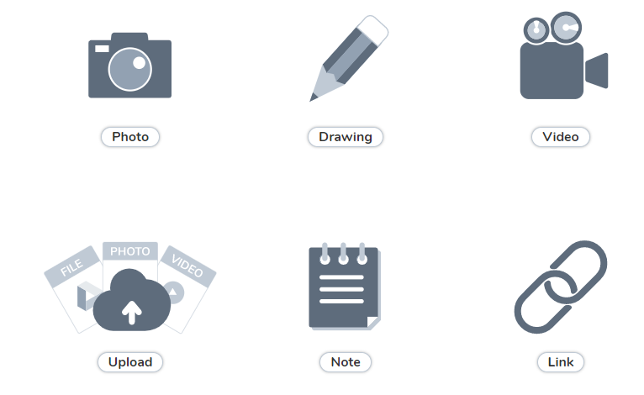
- If your teacher sets you work on the Home Learning section of the school website and wants you to return your work via Seesaw, click on the green ‘Add’ button on your journal. Click on ‘Photo’ and take a photo of your work. Make sure you take a good quality photo. Click on the green tick to submit your work.

