St Mary’s Primary School
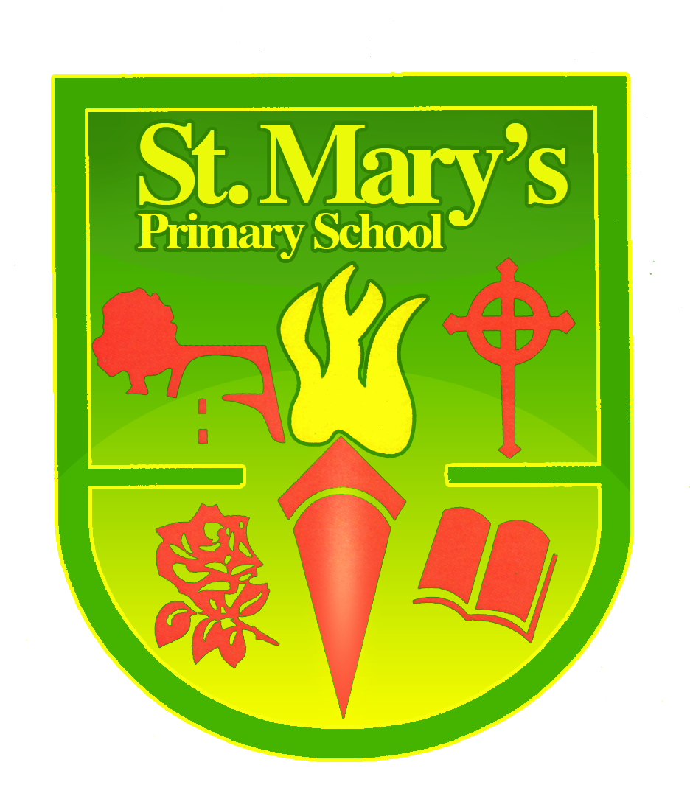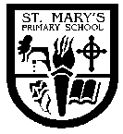
Reilly Park, Banbridge,
Co. Down, BT32 3DJ
www.stmarysbanbridge.co.uk
info@stmarys.banbridge.ni.sch.uk

Telephone: (028) 406 62572 Fax: (028) 406 26545
Principal: Mr. D. O’Hagan B.Ed., NPQH., M.Ed

12th August 2025

Dear Parent/Carer

P2, P3, P4 induction morning will be Thursday 28th August 9.00am to 12.00pm

P5, P6, P7 induction morning will be Friday 29th August 9.00am to 12.00pm

A healthy snack and a bottle of water should be supplied for the day. Our Healthy Eating & Lifestyle Policy is available on our website. Nut Avoidance! Please avoid sending any foods containing nuts or nut traces. We have many children with allergies who require access to an EpiPen.

Pupils may enter their classrooms directly in the mornings from 8.45am. All pupils should use their outside classroom door. P4 children should use the main entrance (upstairs). P3 children are to use the downstairs entrance. Children attending the Specialist Provision classes and Autism Specific Class are to use their normal doors.

The school car park is for staff parking only. Please use St Therese carpark for parking.
A Blue Badge must be displayed to use the disabled bays. Please remind your child/ren to always use the footpath and crossings and not to walk through the carpark. All vehicles must use the one-way system. Vehicles are not permitted to exit the main entry gate at any time. The drop off area to the left of the gate is only for school deliveries, taxis, and parents escorting children who attend our Autism Class or Learning Supports Classes. Signage is in place.

School Finishing Times

P1 at 1.45pm
P2 & P3 at 2.00pm
P4 & P5 at 3.00pm
P6 & P7 at 3.00pm

School finishes at 2.00pm for P4 to P7 on Fridays.

School meals will be available from Monday 1st September. Please use the school app to book. Booking is essential by 8.30am each Monday morning of the incoming week. Free School Meals/Uniform grants can be applied for at the following link
https://www.eani.org.uk/parents/pupil-applications-and-grants/free-school-meals-and-uniform-grants/apply-for-free-school

Breakfast Club will open from 7.45am on Monday 1st September. Please use the school app to book. Booking is essential. Please inform Breakfast Club staff of your child’s medical, allergies and behavioural needs. Breakfast Club will cost £3.00 per session.

Afterschool Club will open as normal from Monday 1st September. Booking is essential. Please contact the Afterschool Club Team on schoolnaomihull12@hotmail.com

Full school uniforms are expected to be worn. Please ensure that all your child’s belongings are clearly labelled with your child’s name. Please note the only jewellery allowed is a watch and stud earrings.

Children will be informed when their PE days are going to be when they return to school. On PE days, children should attend wearing suitable PE clothing.

Children are not allowed mobile phones in school. Mobile phones will be confiscated and will only be returned to parents.

It is ESSENTIAL that all parents and carers download the school app and update their preference to your child’s new class for the new academic year. This is the main means of communication with parents and is the only way to book and pay for school dinners. Instructions are available on the school website at https://storage.googleapis.com/siteassetsswd/60/downloads/20230813053113_19_newappletter8sept.pdf

Teachers regularly post photographs of their class; their pupils work and sporting and other achievements on the school website. Our PTA does likewise on their Facebook page and website. Please inform the school by writing to the school Principal Mr O’Hagan if you DO NOT wish your child to have his/her picture posted on our website or PTA page or be part of our school library Instagram account.

Yours sincerely,
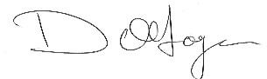
D O’Hagan
Principal

